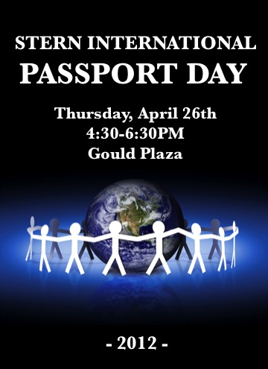

What is Passport day?

- An event hosted by international students to share their country’s culture – over 30 countries represented: students serve food from their native countries to fellow classmates

- Date and time of event: Thursday, April 26, 2012 from 4:30pm to 6:30pm

- Location: Gould Plaza, New York University, Leonard N. Stern School of Business, 44 West Fourth Street, New York, NY 10012

- People are entertained with cultural / traditional costumes, music and performances

- The BIGGEST event at NYU Stern – over 1,500 people in attendance

- Event where future NYU Stern MBA students are recruited

The Benefits

International Passport Day is a fantastic opportunity to have your company publicized prominently at an event full of local graduate students who will be New York’s future business leaders.

- Your company is showcased to 600 potential new customers

- Opportunity to promote your business through flyers, menus, and business cards

- Have your company banner or logo displayed prominently along with particular country displays and dishes!

- Placement of your company logo in the International Passport Day promotional billboard prominently displayed at the reception table

- Placement of your company logo on the Passport Day website

How to Become a Sponsor

- Sponsorship packages

- Platinum – Premier placement on all marketing material and sponsorship announcement during country performances ($200)
- Sponsor – Promote your business through flyers, menus and business cards and logo placement on website (any contribution is appreciated)

Thank you for your interest, and we look forward to working with you on this upcoming International Passport Day!

For more information, visit: http://nyustern.campusgroups.com/international/passport-day/

